**Producer Price Indices in Industry,   
APRIL 2025**

1. **Total Producer Price Indices in Industry**

**The Total Producer Price Index in Industry** fell by 4.4% in April 2025 compared to the previous month. A decrease of 13.0% was registered in the electricity, gas, steam and air conditioning supply, in the manufacturing industry it decreased by 1.0%, and in the mining and quarrying industry - by 0.9%.

Lower prices in the manufacturing industry were registered in the manufacture of basic metals - by 4.4%, in the manufacture of leather and related products - by 3.2%, and in the manufacture of chemicals and chemical products - by 2.7%. An increase was seen in the manufacture of rubber and plastic products - by 1.0%, in the manufacture of food products - by 0.7%, and in the manufacture of electrical equipment - by 0.6%.

**The Total Producer Price Index** went up by 12.3% in April 2025 compared to the same month in 2024. An increase was observed in the electricity, gas, steam and air conditioning supply - by 39.4%, in the mining and quarrying industry - by 23.9%, as well as in the manufacturing industry - by 8.7%.

In the manufacturing, the prices rose in the manufacture of food products - by 25.2%, in the manufacture of basic metals - by 20.4%, and in the manufacture of textiles - by 14.0%. Price reduction was registered in the manufacture of tobacco products - by 12.4%, and in the manufacture of furniture - by 7.3%.

**Figure 1. Total Producer Price Indices in Industry**

**(2021 = 100)**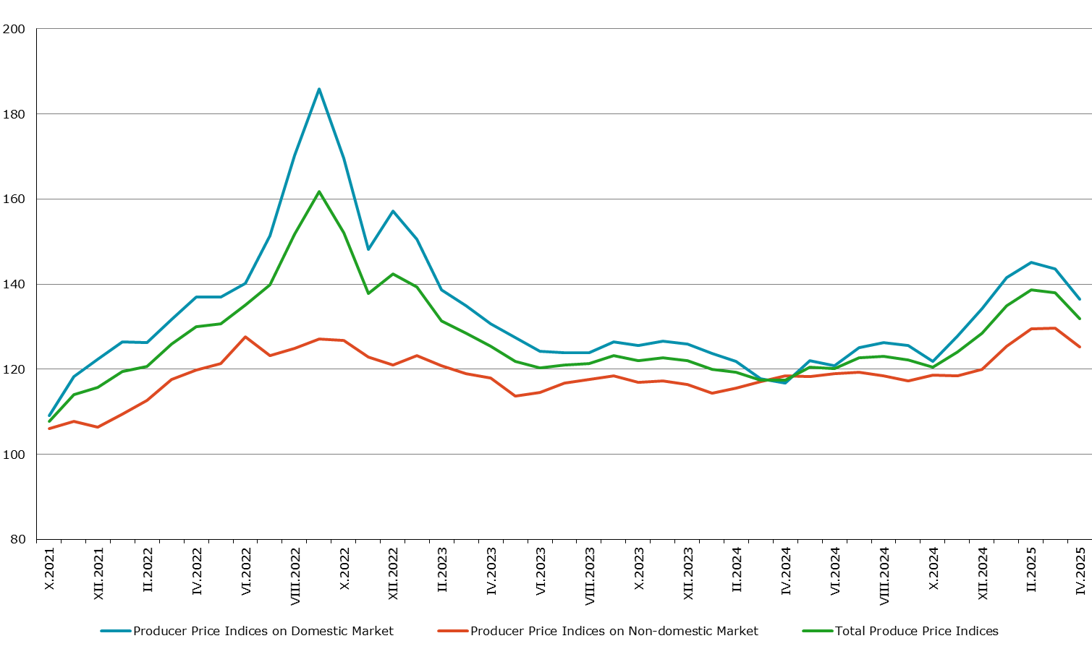

1. **Producer Price Indices on the Domestic Market**

**The Producer Price Index on the Domestic Market** decreased by 5.0%in April 2025 compared to March 2025. The domestic prices fell in the electricity, gas, steam and air conditioning supply - by 11.3%, and in the manufacturing industry - by 0.7%, while in the mining and quarrying industry an increase of 1.0% was reported.

In the manufacturing, compared to the previous month, lower prices were registered in the manufacture of leather and related products - by 8.4%, in the manufacture of chemicals and chemical products - by 4.1%, and in the manufacture of basic metals - by 1.8%. The prices went up in the manufacture of wearing apparel and in the printing and reproduction of recorded media - both by 0.6%, as well as in the manufacture of computer, electronic and optical products - by 0.5%.

**The Producer Price Index on the Domestic Market** went up by 16.9% compared to April 2024. The prices rose in the electricity, gas, steam and air conditioning supply -   
by 47.9%, in the mining and quarrying industry - by 22.2%, and in the manufacturing industry - by 10.1%.

In April 2025, higher prices in the manufacturing in comparison with April 2024 were seen in the manufacture of food products - by 31.6%, in the manufacture of electrical equipment - by 19.6%, in the manufacture of basic metals - by 18.7%, and in the manufacture of beverages - by 18.6%. Lower prices were reported in the manufacture of leather and related products - by 12.9% and in the manufacture of motor vehicles, trailers and semi-trailers - by 8.4%.

**Figure 2. Producer Price Indices on the Domestic Market in Industry**

**(2021 = 100)**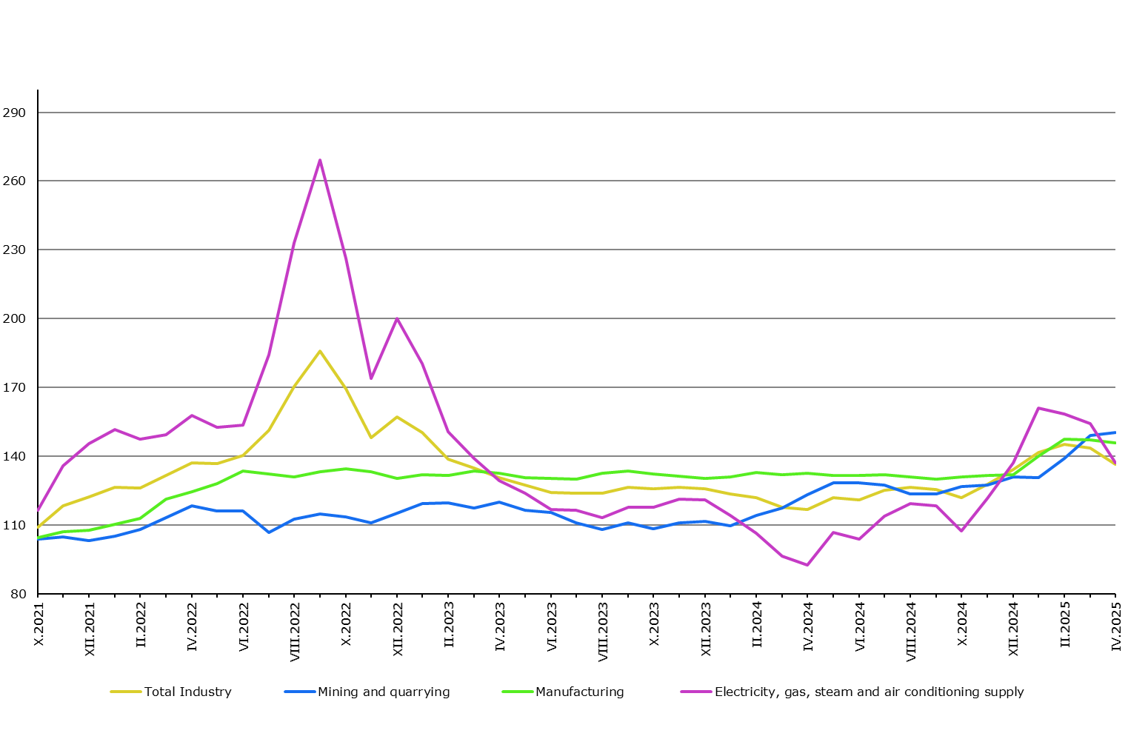

1. **Producer Price Indices on the Non-domestic Market**

**The Producer Price Index on the Non-domestic Market** fellby 3.4% in April 2025 compared to the previous month and rose by 5.8% in comparison with April 2024.

**Methodological notes**

Producer Price Indices measure the average change in the prices of industrial products, which are produced and sold by Bulgarian enterprises. They can be considered an early measure of the current inflation process in the economy and they can be used for international comparisons. Information for the calculation of Producer Price Indices is received on the basis of monthly surveys on producer prices of industrial products sold on the domestic market and on industrial products sold on the non-domestic market. Producer price surveys are based on a constant sample of groups of products, and that sample is representative of the total industrial production.

Total Producer Price Indices are calculated from Producer Price Indices on the Domestic Market and Producer Price Indices on the Non-domestic Market, weighted with the turnover structure on the domestic and the non-domestic market to the total value of turnover in the base year (2021).

Producer Price Indices on the Domestic Market are calculated at a constant base (2021), weighed with the turnover structure on the domestic market.

Producer Price Indices on the Non-domestic Market are calculated at a constant base (2021), weighed with the turnover structure on the non-domestic market.

**Annex**

**Table 1**

**Total Producer Price Indices in April 2025**[1]1

|  |  |  |  |
| --- | --- | --- | --- |
| **Economic activities** | **2021 = 100** | **The previous month = 100** | **The same month of the previous year = 100** |
| **Industry** | **131.9** | **95.6** | **112.3** |
| **Mining and quarrying** | **152.2** | **99.1** | **123.9** |
| Mining of coal and lignite | 283.0 | 112.3 | 211.4 |
| Extraction of crude petroleum and natural gas | .. | **..** | **..** |
| Mining of metal ores | 124.3 | 92.9 | 109.2 |
| Other mining and quarrying | 149.4 | 100.9 | 102.8 |
| Mining support service activities | .. | .. | .. |
| **Manufacturing** | **136.9** | **99.0** | **108.7** |
| Manufacture of food products | 162.2 | 100.7 | 125.2 |
| Manufacture of beverages | 145.7 | 98.4 | 113.4 |
| Manufacture of tobacco products | 131.1 | 100.0 | 87.6 |
| Manufacture of textiles | 146.3 | 100.0 | 114.0 |
| Manufacture of wearing apparel | 138.2 | 100.5 | 111.8 |
| Manufacture of leather and related products | 108.6 | 96.8 | 101.6 |
| Manufacture of wood and products of wood and cork, except furniture; manufacture of articles of straw and plaiting materials | 137.0 | 100.5 | 103.6 |
| Manufacture of paper and paper products | 135.7 | 100.3 | 111.0 |
| Printing and reproduction of recorded media | 134.5 | 100.5 | 108.0 |
| Manufacture of coke and refined petroleum products | .. | .. | .. |
| Manufacture of chemicals and chemical products | 126.6 | 97.3 | 108.2 |
| Manufacture of basic pharmaceutical products and pharmaceutical preparations | 116.8 | 98.7 | 104.4 |
| Manufacture of rubber and plastic products | 150.5 | 101.0 | 110.7 |
| Manufacture of other non-metallic mineral products | 164.5 | 99.9 | 109.8 |
| Manufacture of basic metals | 126.9 | 95.6 | 120.4 |
| Manufacture of fabricated metal products, except machinery and equipment | 140.7 | 100.1 | 110.1 |
| Manufacture of computer, electronic and optical products | 143.1 | 99.8 | 106.9 |
| Manufacture of electrical equipment | 136.7 | 100.6 | 109.9 |
| Manufacture of machinery and equipment n.e.c. | 128.6 | 99.9 | 99.3 |
| Manufacture of motor vehicles, trailers and semi-trailers | 113.3 | 99.7 | 101.6 |
| Manufacture of other transport equipment | 109.2 | 99.8 | 102.5 |
| Manufacture of furniture | 123.1 | 99.9 | 92.7 |
| Other manufacturing | 106.6 | 99.0 | 101.7 |
| Repair and installation of machinery and equipment | 134.4 | 100.0 | 104.4 |
| **Electricity, gas, steam and air conditioning supply** | **128.8** | **87.0** | **139.4** |
| Electricity, gas, steam and air conditioning supply | 128.8 | 87.0 | 139.4 |

**Table 2**

**Producer Price Indices on the Domestic Market in April 2025**[2]1

|  |  |  |  |  |  |  |
| --- | --- | --- | --- | --- | --- | --- |
| **Economic activities** | **2021 = 100** | | **The previous month = 100** | | **The same month of the previous year = 100** | |
| **Industry** | | **136.5** | | **95.0** | | **116.9** | |
| **Mining and quarrying** | | **150.5** | | **101.0** | | **122.2** | |
| Mining of coal and lignite | | 283.4 | | 112.3 | | 210.8 | |
| Extraction of crude petroleum and natural gas | | .. | | .. | | .. | |
| Mining of metal ores | | 113.5 | | 93.9 | | 100.2 | |
| Other mining and quarrying | | 143.5 | | 101.2 | | 100.2 | |
| Mining support service activities | | **..** | | **..** | | **..** | |
| **Manufacturing** | | **146.0** | | **99.3** | | **110.1** | |
| Manufacture of food products | | 175.8 | | 100.4 | | 131.6 | |
| Manufacture of beverages | | 152.6 | | 98.4 | | 118.6 | |
| Manufacture of tobacco products | | 161.6 | | 100.0 | | 97.2 | |
| Manufacture of textiles | | 154.2 | | 100.2 | | 110.7 | |
| Manufacture of wearing apparel | | 141.9 | | 100.6 | | 110.4 | |
| Manufacture of leather and related products | | 122.6 | | 91.6 | | 87.1 | |
| Manufacture of wood and products of wood and cork, except furniture; manufacture of articles of straw and plaiting materials | | 146.5 | | 99.6 | | 97.9 | |
| Manufacture of paper and paper products | | 137.5 | | 100.2 | | 110.5 | |
| Printing and reproduction of recorded media | | 134.9 | | 100.6 | | 106.3 | |
| Manufacture of coke and refined petroleum products | | .. | | .. | | .. | |
| Manufacture of chemicals and chemical products | | 132.8 | | 95.9 | | 110.7 | |
| Manufacture of basic pharmaceutical products and pharmaceutical preparations | | 107.1 | | 99.7 | | 101.4 | |
| Manufacture of rubber and plastic products | | 131.0 | | 100.1 | | 104.4 | |
| Manufacture of other non-metallic mineral products | | 164.3 | | 100.1 | | 107.8 | |
| Manufacture of basic metals | | 122.1 | | 98.2 | | 118.7 | |
| Manufacture of fabricated metal products, except machinery and equipment | | 137.1 | | 100.2 | | 107.8 | |
| Manufacture of computer, electronic and optical products | | 118.7 | | 100.5 | | 101.8 | |
| Manufacture of electrical equipment | | 150.0 | | 100.2 | | 119.6 | |
| Manufacture of machinery and equipment n.e.c. | | 135.3 | | 100.1 | | 104.9 | |
| Manufacture of motor vehicles, trailers and semi-trailers | | 120.1 | | 99.8 | | 91.6 | |
| Manufacture of other transport equipment | | 121.9 | | 100.0 | | 106.9 | |
| Manufacture of furniture | | 158.9 | | 99.9 | | 112.3 | |
| Other manufacturing | | 97.1 | | 99.9 | | 97.3 | |
| Repair and installation of machinery and equipment | | 143.2 | | 100.0 | | 108.0 | |
| **Electricity, gas, steam and air conditioning supply** | | **137.0** | | **88.7** | | **147.9** | |
| Electricity, gas, steam and air conditioning supply | | 137.0 | | 88.7 | | 147.9 | |

**Table 3**

**Producer Price Indices on the Non-domestic Market in April 2025**[3]1

|  |  |  |  |  |  |  |  |
| --- | --- | --- | --- | --- | --- | --- | --- |
| **Economic activities** | | **2021 = 100** | | **The previous month = 100** | | **The same month of the previous year = 100** | |
| **Industry** | **125.3** | | **96.6** | | **105.8** | |
| **Mining and quarrying** | **159.4** | | **92.5** | | **131.5** | |
| Mining of coal and lignite | - | | - | | - | |
| Extraction of crude petroleum and natural gas | - | | - | | - | |
| Mining of metal ores | .. | | .. | | .. | |
| Other mining and quarrying | 170.8 | | 99.9 | | 109.4 | |
| Mining support service activities | **-** | | **-** | | **-** | |
| **Manufacturing** | **129.8** | | **98.7** | | **108.4** | |
| Manufacture of food products | 136.1 | | 101.5 | | 115.4 | |
| Manufacture of beverages | 90.4 | | 97.7 | | 71.6 | |
| Manufacture of tobacco products | 107.8 | | 100.0 | | 99.6 | |
| Manufacture of textiles | 143.7 | | 99.9 | | 117.1 | |
| Manufacture of wearing apparel | 136.6 | | 100.4 | | 112.8 | |
| Manufacture of leather and related products | 101.3 | | 100.3 | | 111.4 | |
| Manufacture of wood and products of wood and cork, except furniture; manufacture of articles of straw and plaiting materials | 123.1 | | 102.1 | | 115.0 | |
| Manufacture of paper and paper products | 133.2 | | 100.5 | | 112.8 | |
| Printing and reproduction of recorded media | 132.8 | | 100.0 | | 121.9 | |
| Manufacture of coke and refined petroleum products | .. | | .. | | .. | |
| Manufacture of chemicals and chemical products | 119.4 | | 99.2 | | 105.1 | |
| Manufacture of basic pharmaceutical products and pharmaceutical preparations | 132.4 | | 97.5 | | 108.4 | |
| Manufacture of rubber and plastic products | 166.4 | | 101.5 | | 114.0 | |
| Manufacture of other non-metallic mineral products | 164.8 | | 99.6 | | 113.2 | |
| Manufacture of basic metals | 128.0 | | 95.0 | | 120.9 | |
| Manufacture of fabricated metal products, except machinery and equipment | 146.7 | | 99.9 | | 113.8 | |
| Manufacture of computer, electronic and optical products | 152.5 | | 99.6 | | 108.8 | |
| Manufacture of electrical equipment | 132.0 | | 100.7 | | 106.5 | |
| Manufacture of machinery and equipment n.e.c. | 126.5 | | 99.8 | | 97.4 | |
| Manufacture of motor vehicles, trailers and semi-trailers | 111.9 | | 99.7 | | 102.4 | |
| Manufacture of other transport equipment | 105.9 | | 99.8 | | 102.9 | |
| Manufacture of furniture | 78.0 | | 99.9 | | 66.8 | |
| Other manufacturing | 111.3 | | 98.7 | | 103.9 | |
| Repair and installation of machinery and equipment | 123.1 | | 100.0 | | 101.3 | |
| **Electricity, gas, steam and air conditioning supply** | **69.5** | | **68.2** | | **79.3** | |
| Electricity, gas, steam and air conditioning supply | 69.5 | | 68.2 | | 79.3 | |

1. 1 ‘..’ - Confidential data.
2. 1 ‘..’ - Confidential data.
3. 1‘..’ - Confidential data.

   ‘-’ - No case registered.